Prompts for FB posts: remember, it’s the process, not the finished product—go with the flow! ID your post.

reference | prompt | helpful hints
Eugene Atget, photographer, 1857-1927  Captured STREET SCENES of Paris and his photos of shop windows seem like Surrealist peeks into another world. 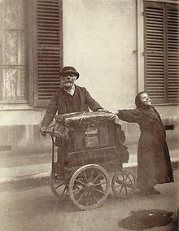 | Take a photo of a street scene or close-up detail. Develop a caption that includes fact and imagination (location + your subjective observation or thought or free association). | Photo of something that catches your eye: a sign in another language, someone reading or sleeping, glimpse of street fashion.
Mavis Gallant, American writer, 29 yrs old, Paris-Rome-Madrid diaries, 1952. “Grey stone houses, balconies, trolley lines, dust. Like a bourgeois Paris suddenly deserted, disappearing under grit and sand.” As an emerging writer, she practiced keen observation, jotting down FIRST IMPRESSIONS of streets, people, scenes.  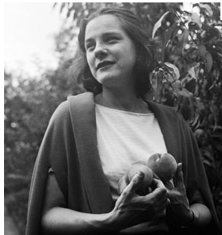 | Take a close-up picture in your head. Freeze the image. Write specifically—what you observe, how you feel about it—combining the concrete + abstract. | Step one: record what your mind’s eye sees in the moment. Two: record your emotion or random association with what you see.
FOUND LANGUAGE   | Take a picture or write down any language you notice as you walk around—signs, menus, graffiti, trash, a phrase from your guidebook or English-French dictionary. | First, let the found language tell a story—note Brick Lane sign includes Bengali, of a colorful immigrant neighborhood in East London. Then, add a line of your own observation or a fact about it, such as “Take-out curry is just as English as fish and chips.”
JUXTAPOSE two disparate images or of image+text  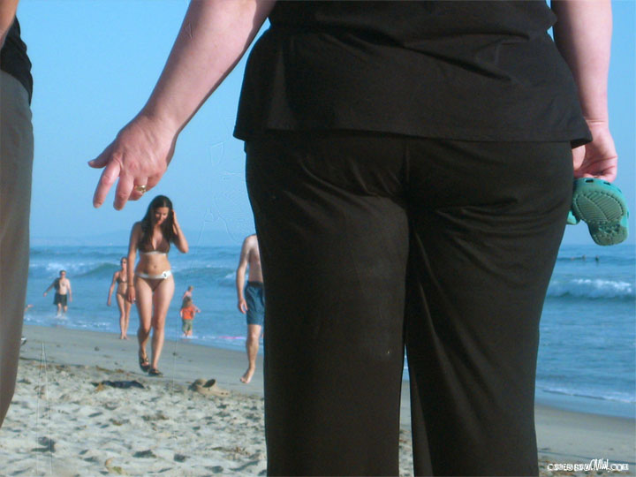 | Take a picture of seeming opposites or an unexpected combination. In this scene, a girl in a bikini and a woman fully clothed in black. | Look for opposites: young and old, old / new, big / small, traditional / modern. Or, a picture that suggests one thing and a sign that says another.
Novels in Three Lines by Felix Feneon  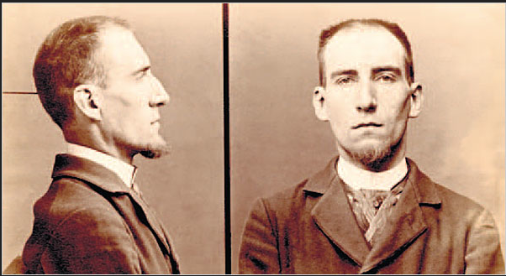  “He had bet he could drink 15 absinthes in succession while eating a kilo of beef. After the ninth, Theophile Pain, of Ivry, collapsed.” | Unlike Feneon, do not allow yourself to get arrested for anarchy. Like Feneon, look over the day’s NEWS for an odd-ball or shocking item. Copy no more than 3 lines. | We often stumble upon stories told in a nutshell. Or, a headline that suggests more than one thing. Snatch a few lines and cite the source. Let the reader fill in the rest.
What if? Anne Bernays and Pamela Painter    What = what is there in reality.  What if = what we see in imagination. | You are sitting in a café. WHAT IF that man across the room is a spy? You are falling asleep in your room. What if the previous occupant was stabbed psycho-style in her sleep? | In 1 or 2 lines, describe a mundane situation. Then, add a “what if.” And then, add another line or two to that imagined scene.
"The noise, the crowd, the glare of the shops agreeably confused me." By 22-yr old James Boswell on why he loved London, 1763.  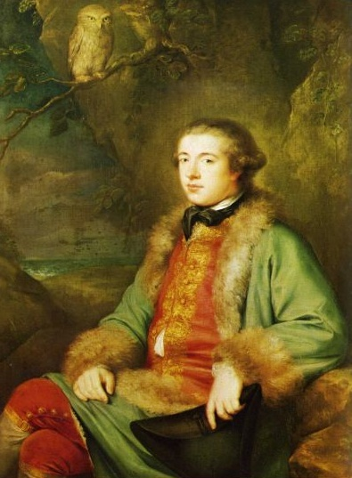 | Sometimes we think of OLD WORLD cities as “dirty, bustling and bawdy,” a mess of contradicting impressions. Take a mental “snapshot” of 2 or more contradicting impressions. Briefly describe each and how, together, the confusion arises. | First, record your impressions. Then, comment. What is pleasing about travel? Confusing? Or, does the contradiction lie elsewhere—your expectation v. your experience?
“My Darling, I hope you will forgive me if I tell you something that I feel you ought to know…You are not so kind as you used to be…your loving devoted & watchful Clemie”  Letter from wife Clementine to prime minister Winston Churchill, 1940, during onset of WWII and mounting tensions. <http://www.lettersofnote.com/2012/08/you-are-not-so-kind-as-you-used-to-be.html>  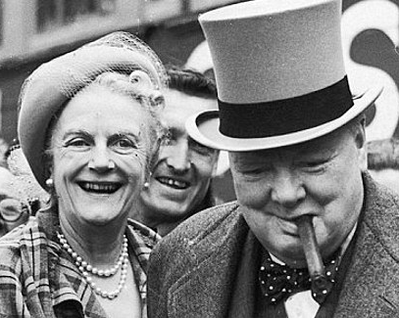 | Real or imagined personal communication of the famous or celebrities help us understand history and our world. Write a phone text or tweet involving a London or Paris celebrity.  To Beckham, Queen Elizabeth, Shakespeare, Mick Jagger, Billy Idol, Napoleon,Voltaire, Marquis de Sade, Princess Di, Brigitte Bardot, or book/movie character… | First, think of a person (long dead or alive) linked to London or Paris who fascinates you.  Write a text or tweet to that person, as either a FRIEND, FOE, OR FAN. Be as specific as possible, referring to a particular thing as evidence of your concern or fandom. ID text as to ____ from ____. Optional: upload photo.
“I go out every day. When I get depressed at the office, I go out, and as soon as I'm on the street and see people, I feel better. But I never go out with a preconceived idea. I let the street speak to me.”  “The best fashion show is definitely on the street. Always has been, and always will be.”  —Bill Cunningham, NYT | 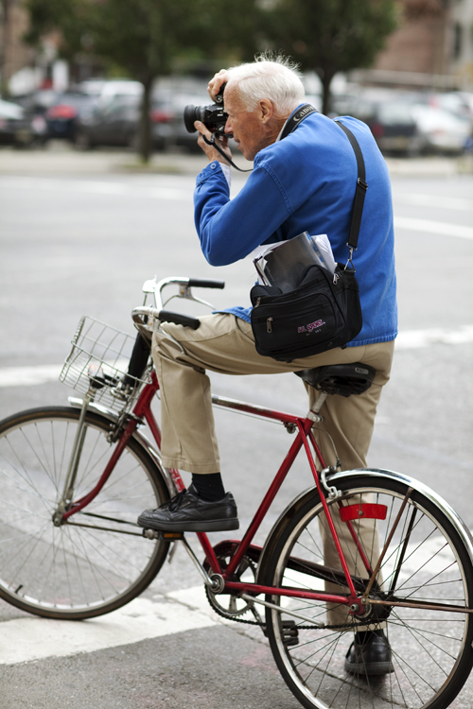 | Stoke your FASHIONISTA gland as you walk around. We usually think of trendsetters as high-fashion designers and models. Turn it around: look for creative expression on the street—especially among kids and young adults who like to push boundaries of taste—weird or surprisingly plush outfits that break the rules and make up their own.  Snap quickly, just like Bill Cunningham!
Curious Behavior: Yawning, Laughing, Hiccupping, and Beyond (Belching, Farting) by Robert Provine. “Everyday life is teeming with the important and unexpected, if you know where to look and how to see.”  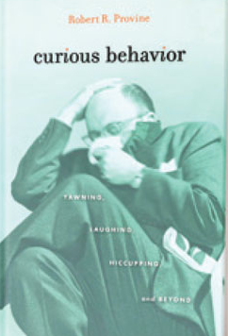 | Apply the “small science” of keen observation (requiring no special knowledge or equipment). What EVERYDAY BEHAVIOR of your fellow travelers or of people on the street strike you as notable? State in “small science” terms.  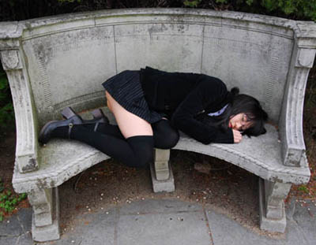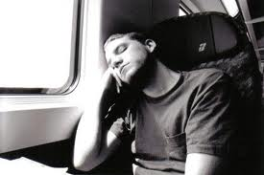 | Zero in on everyday behavior, such as waiting in line or sitting on the bus. Using your eyes and ears as scientific instruments, describe what you observe in one person or a pattern among a group. Photo optional.  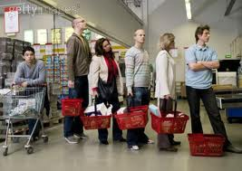
http://www.brainpickings.org/index.php/2012/01/05/samuel-beckett-notebooks/  Samuel Beckett’s notebook DOODLES  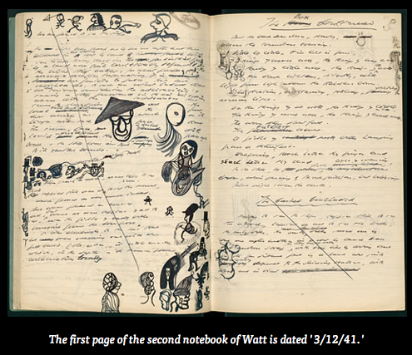 | 20th c. writer Samuel Beckett combined doodles and handwritten notes in his notebooks. Even if you don’t consider yourself an artist, start to doodle as you wait in line, ride the bus, sit in a café. What’s a doodle? Something you sketch while doing something else, such as drawing a cartoon or pattern while talking on the phone. A doodle can be a way into words – drawing without thinking directly about something.  ____________________________  DOCUMENTARY = record in words and pictures exactly what you observe and do. From getting ready  travel  returning home.  DOCUMENTARY SERIES = a series of pictures and captions of one thing, such as menus or signs or shoes or hands or windows… | Doodle in your notebook without judging what you draw. There’s no such thing as a mistake with a doodle. A doodle is a doodle, nothing more, nothing less. Try doodling as a habit, while eating or talking. Mix it up – doodle + a phrase or sentence. It is not necessary for the words and doodle to match or to make sense. Then, snap a photo of your doodle and post.  _______________________  Packing. Your pet. Your doorstep. View from your house window. View from your hotel window.  Passport, keys, money, sunglasses, airport. A fellow traveller sleeping, eating, laughing, bored, reading, waiting…a straight record. Facts: date, time, place.

